# SNF

**Criteria:**

1. Relative amp of Ptot > 0. 5

2. max(Ptot) is minimized s.t Kd is maximized

Found 1014 sets.

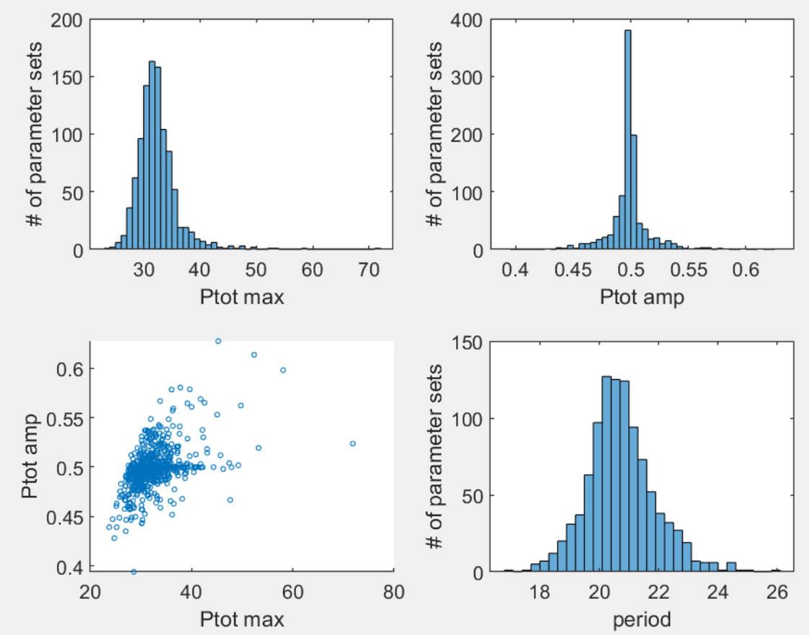

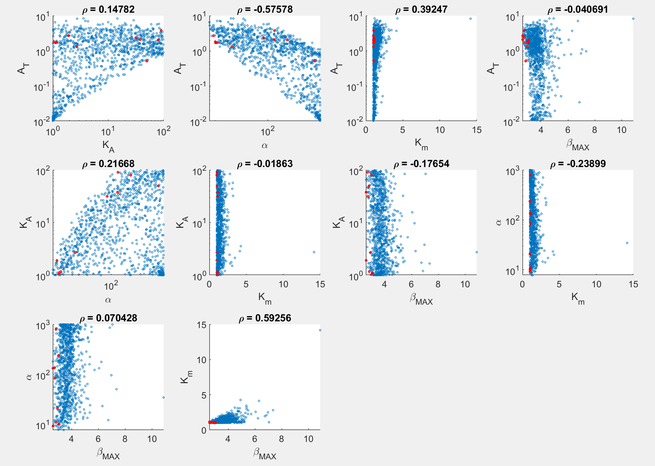

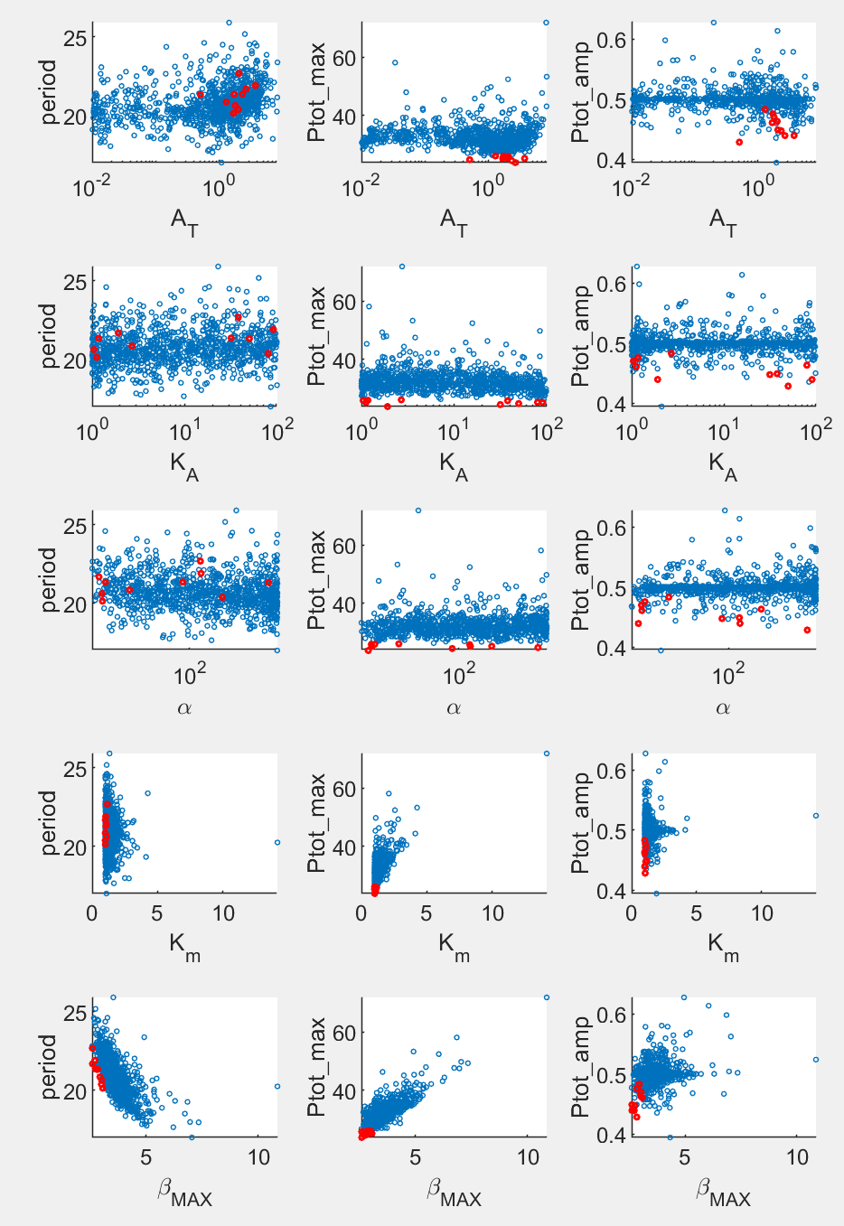

Main patterns:

1. Low max(Ptot) requires low Km and beta_max. This is not surprising, as lower values in both parameters slow down PER degradation, introduce time delay and thus increase robustness of oscillation (hence allowing oscillation to happen for larger Kd).
2. To achieve low max(Ptot), AT also seems to be restricted to a narrow region. I guess this is because Km and beta_max are restricted a narrow region to achieve low max(Ptot). This may entail an optimal AT to best work with the resulting degradation rate of P_nuc.
3. Alpha and AT are negatively correlated for more sets. This result is opposite to the trend in L models, although this comparison is not done between the same type of diagrams.
4. Alpha and KA positively correlated, located on a narrow band.
5. Period strongly correlated with beta_max. This is not surprising, as beta_max determines the time delay. The top 10 sets generate intermediate periods between 20 and 23.

# NNF

**Criteria: (new criterion highlighted)**

1. Relative amp of Ptot > 0.5

2. max(Ptot) is minimized s.t Kd is maximized

~~3. BMAL (At) average level matches SNF model~~

4. Relative amp of BMAL > 0.2

~~5. Period of Ptot matches SNF~~

6. max(Rev) < 10

7. max(AT) / max(Ptot) as close to 1 as possible

Found 1011 sets w/ additional criterion for max(AT).

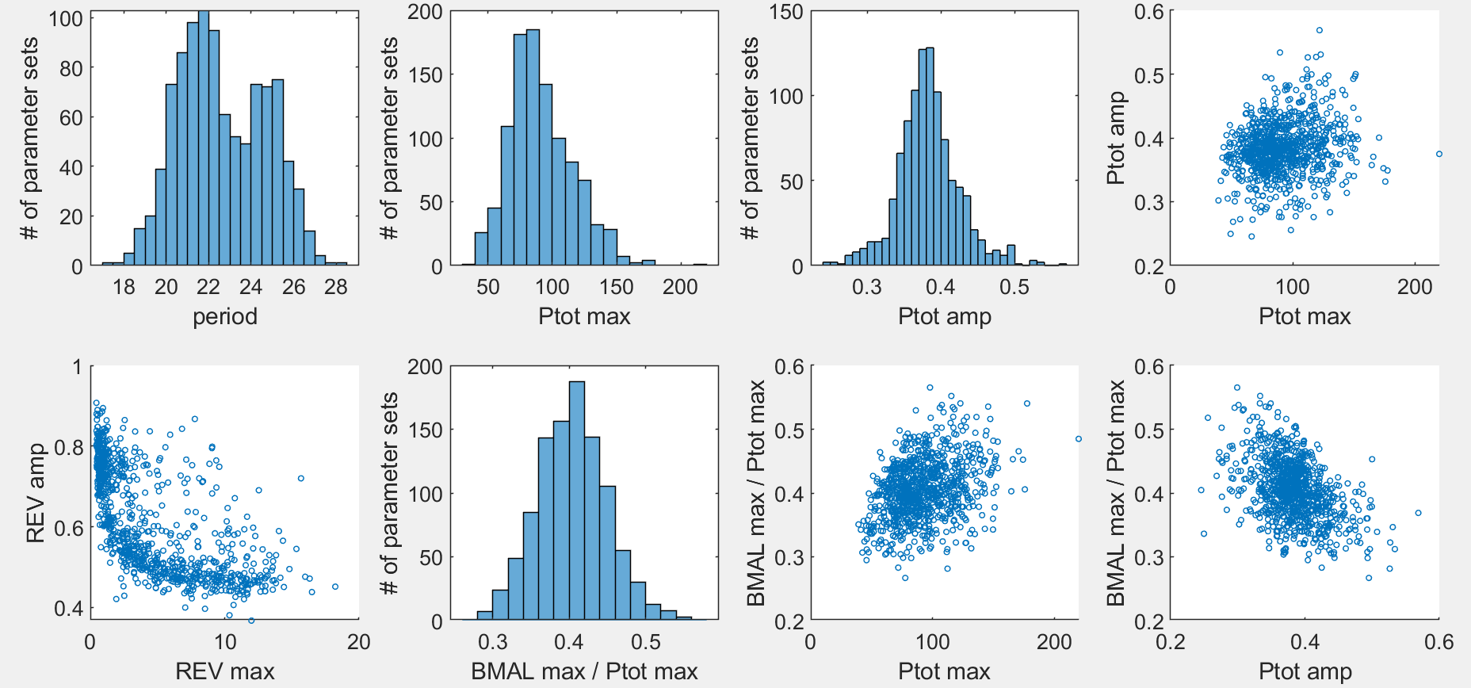

Pattern:

1. With the constraint on max(AT), NNF actually performs slightly worse than SNF in terms of max(Ptot).

The following plots show data of the points with the best combination between max(BMAL)/max(Ptot) and max(Ptot). Xiangyu may check how their corresponding 2-param bifurcation diagrams look.

|  |  |
| --- | --- |
| Original NNF | NNFd2 |
|  |  |

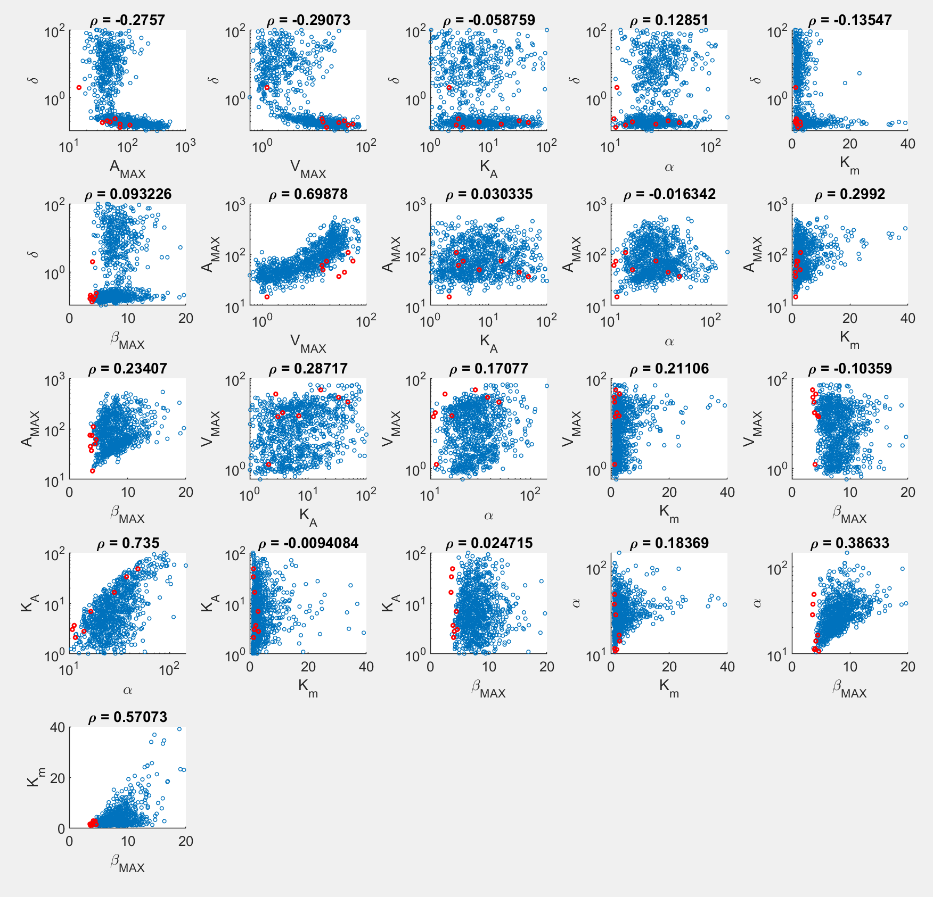

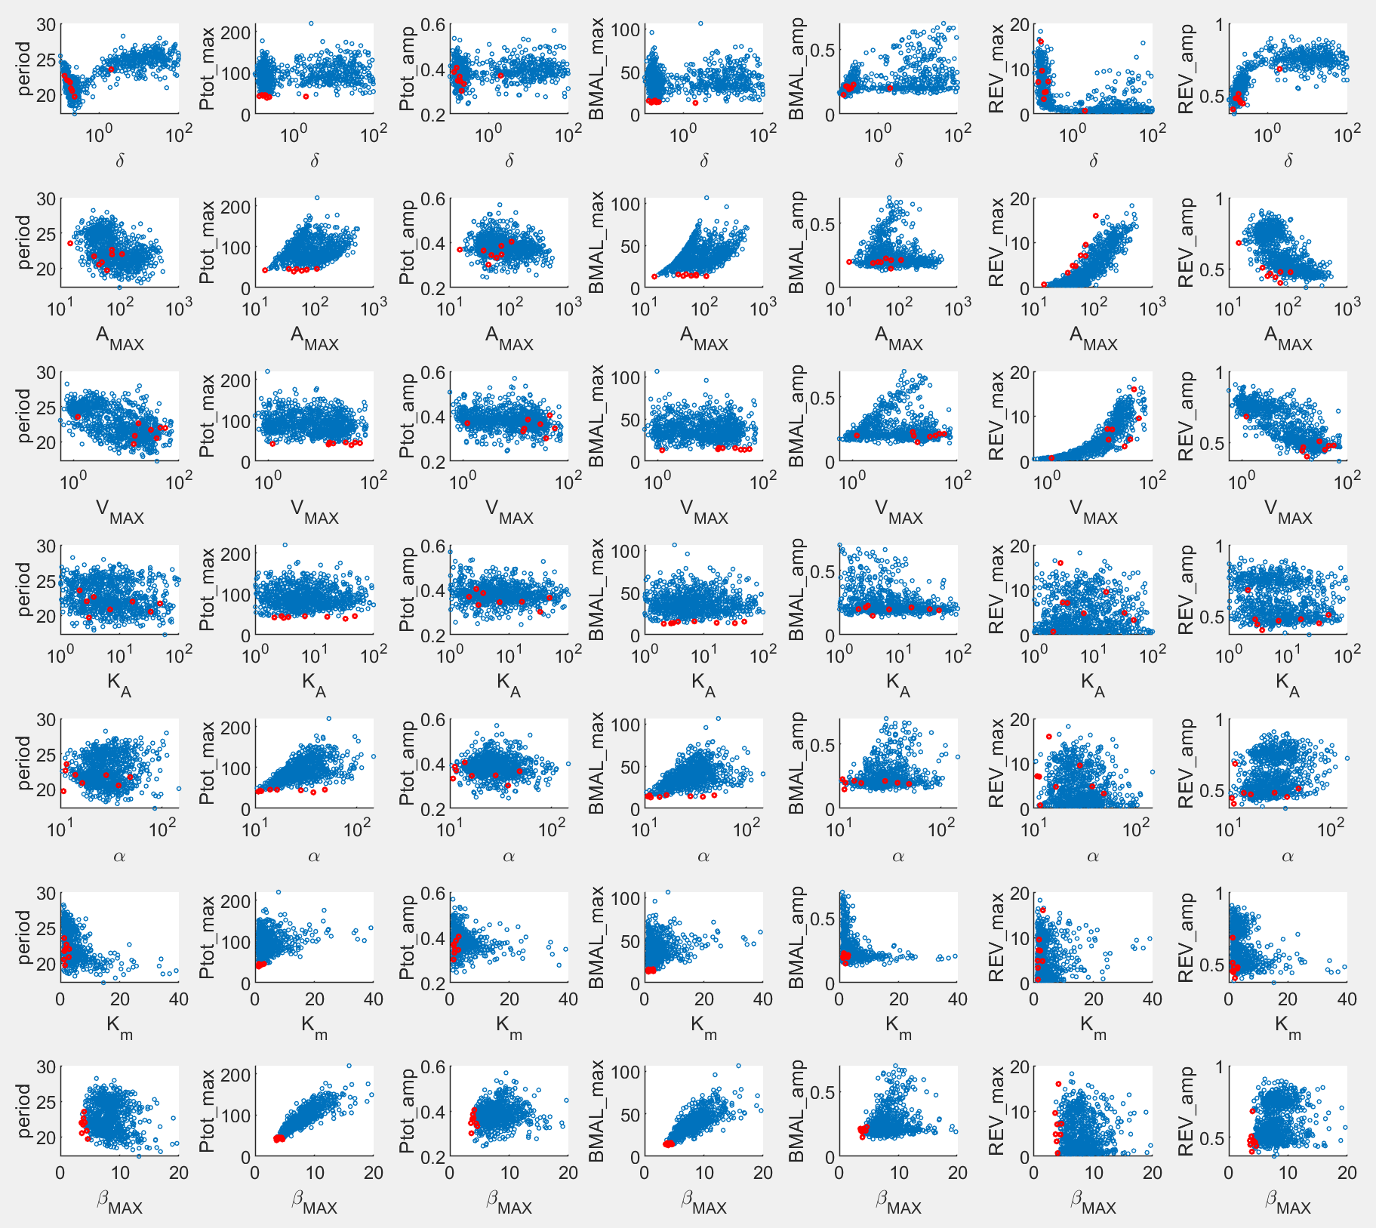

Main patterns:

1. Low max(Ptot) requires low Km and beta_max, like in SNF.
2. There appear to be two clusters, a larger cluster with small delta ~0.1 and a smaller cluster with larger delta. The majority of top sets are in the larger cluster.
3. AMAX are positively correlation with VMAX. But this trend was not significant in the old run without the constraint on max(AT). So I wouldn’t consider this pattern important.
4. Opposite to the above point, alpha and AMAX are negatively correlated in the old result, but not here. So I’d also forgo this one.
5. Max(Ptot) and max(BMAL) are most sensitive to beta_max, followed by alpha and Km.
6. Period is strongly correlated with beta_max (figure below). This is not surprising, as beta_max determines the time delay. Top 10 sets again generate intermediate periods, like SNF.

# PNF

**Criteria:**

1. Relative amp of Ptot > 0.5

2. max(Ptot) is minimized s.t Kd is maximized

~~3. BMAL (At) average level matches SNF model~~

4. Relative amp of BMAL > 0.2

~~5. Period of Ptot matches SNF~~

6. max(Ror) < 5

7. max(AT) / max(Ptot) as close to 1 as possible

Found 952 runs w/ additional criterion for max(AT);

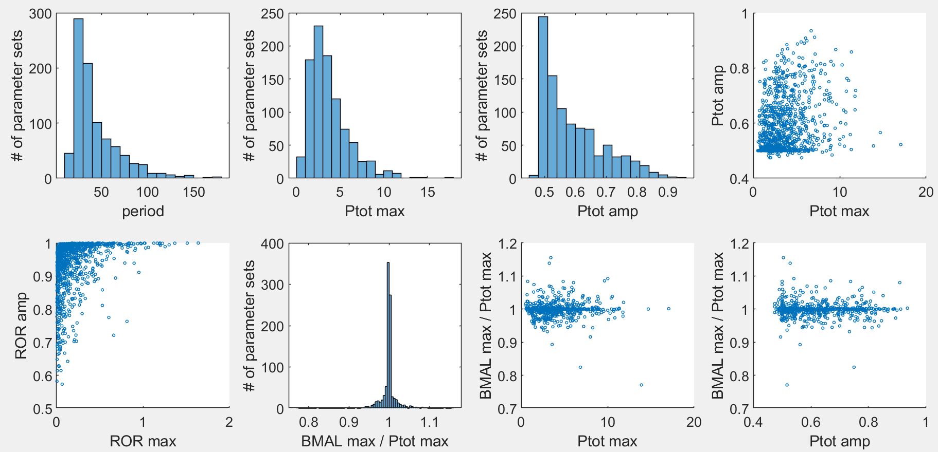

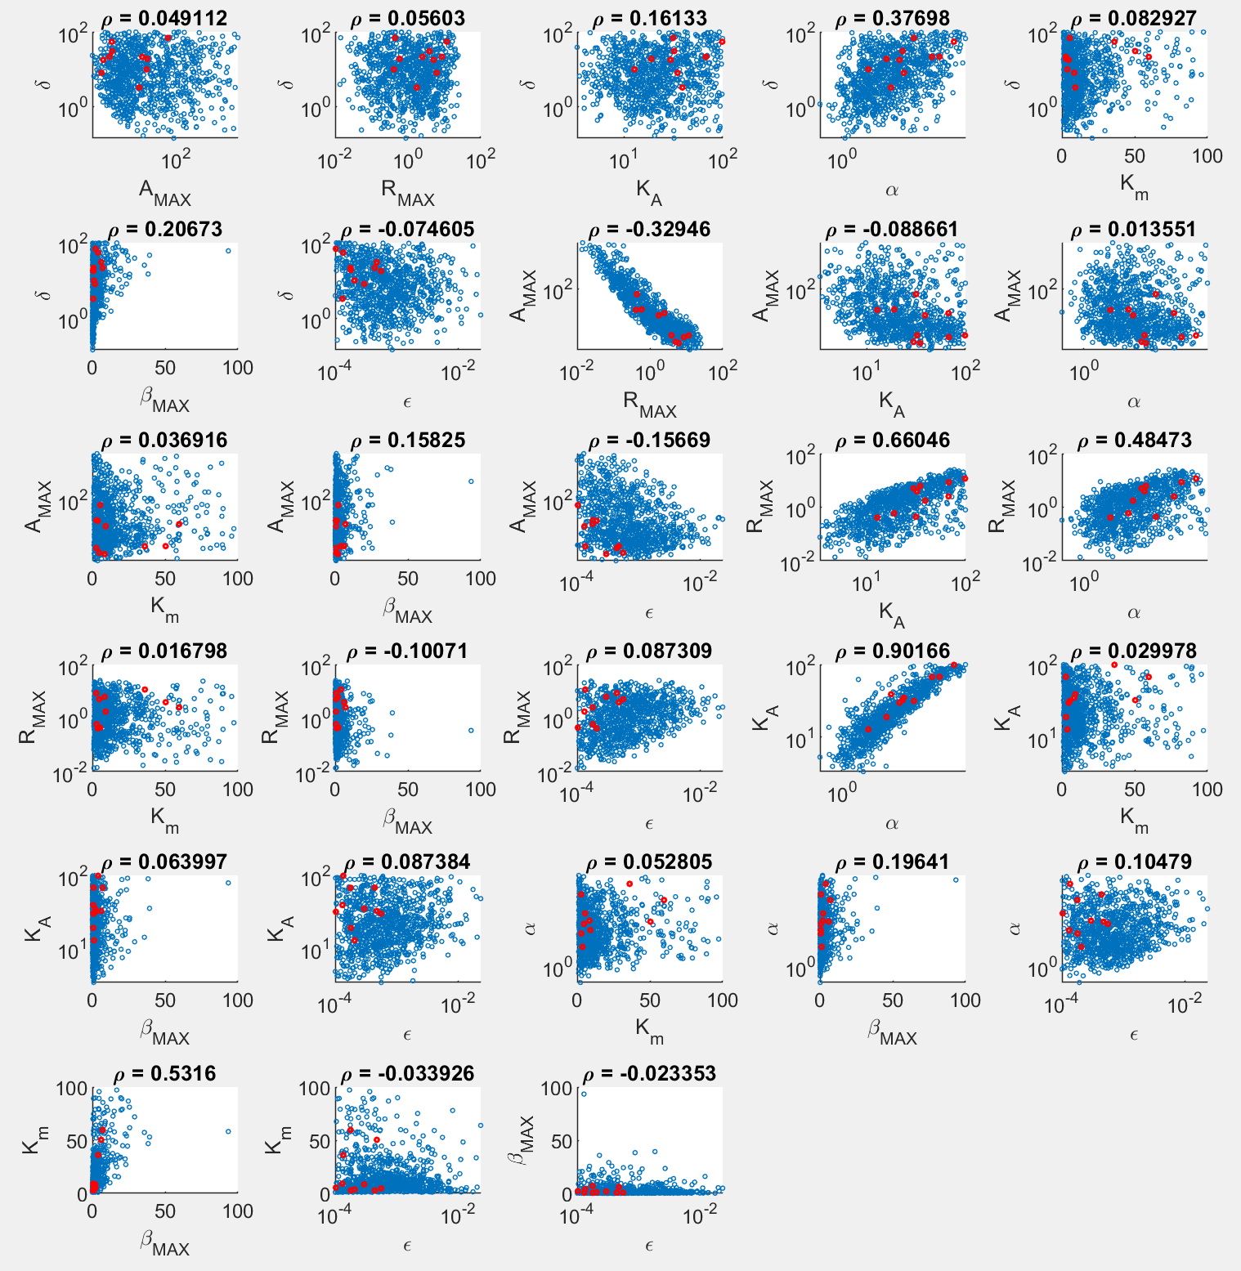

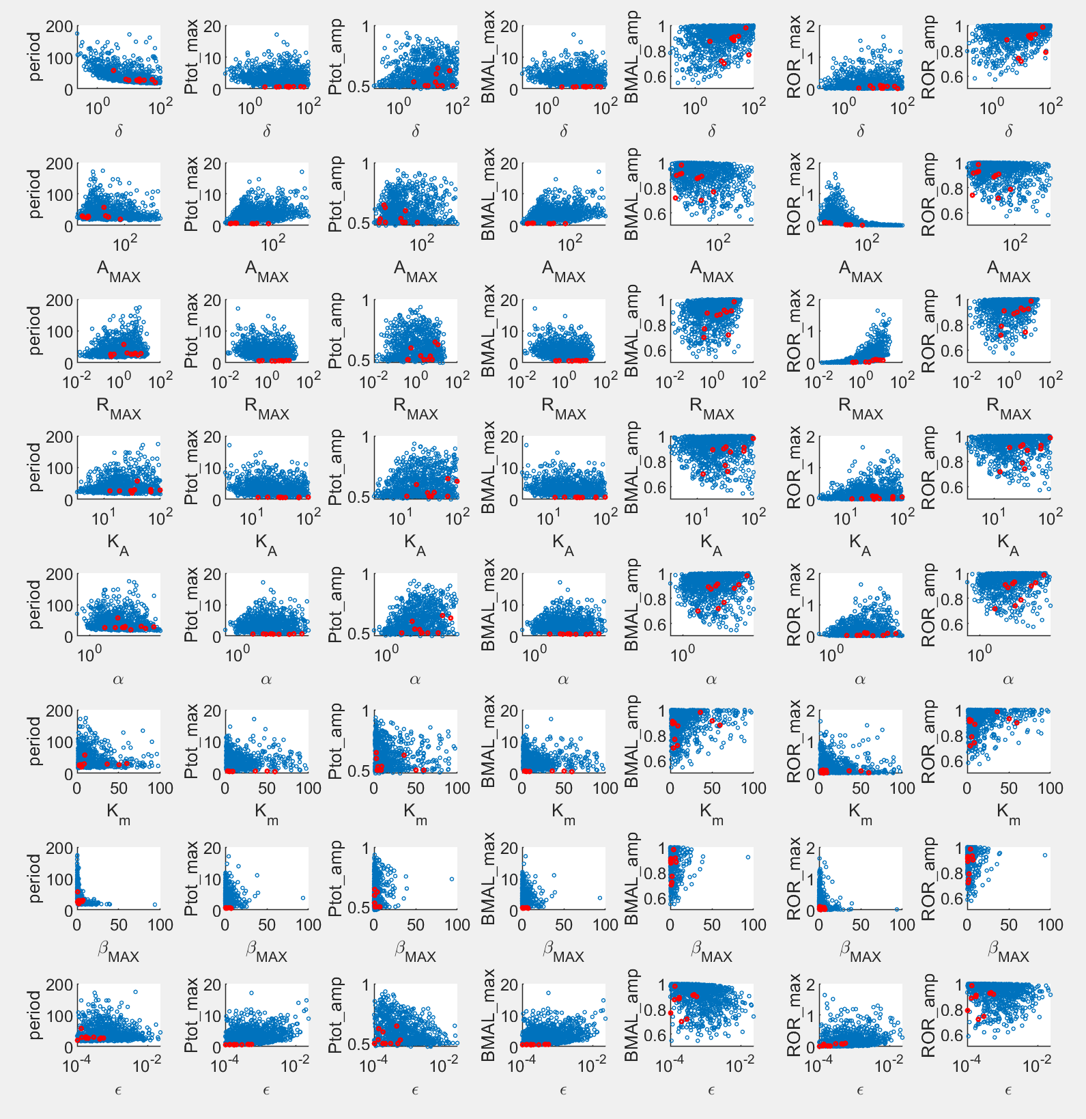

Main patterns:

1. Low max(Ptot) still requires low beta_max, but is more relaxing on Km.
2. Delta needs to be sufficiently large.
3. Eps needs to be sufficiently low.
4. AMAX and RMAX are negatively correlated (also so w/o the constraint on max(AT)).
5. RMAX and alpha are correlated (also so w/o the constraint on max(AT)). In the new set, KA also becomes correlated with Rmax and alpha.
6. Alpha and KA are positively correlated, but this was not the case w/o the constraint on max(AT). So maybe not important.
7. Overall, PNF still easily gives sets that fit our criteria. To make BMAL level more equal to PER level, just need larger Amax and a more finely tuned KA.
8. Period strongly depends on beta_max and delta. Top 10 sets again generate intermediate periods.